**User Story**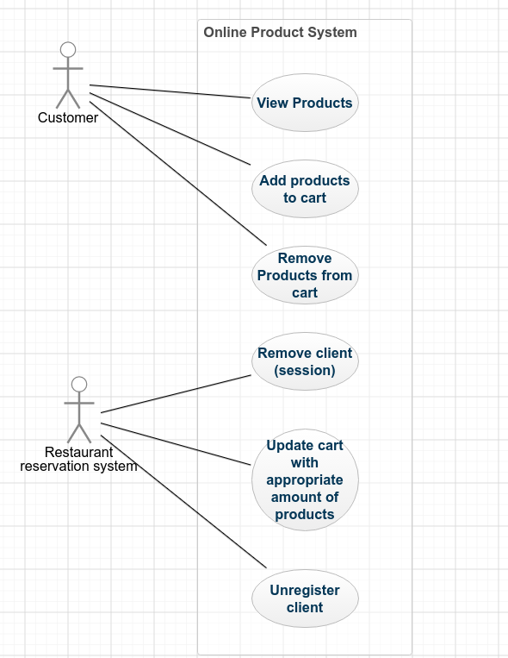

Order Foods

1. The user will be presented with an opening page that will have the products that the restaurant offers with various different types of filters.

2. The first filter will consist of different types of meals that are served at the restaurant, which include, breakfast, lunch, and dinner.

3. The next filter is the maximum price that they are willing to pay for a specific meal.

4. The filter after that is if they want to look only for healthy meals.

5. The filter after that is to sort the products either by the name of by the price.

6. If the maximum price filter does not filter great results due to not knowing the prices in the restaurant the sort filters ASC and DESC will help so that the customer knows the products from high to low or the products name from high to low.

7. When the user clicks on the product it will show a brief description of the product in the right.

8. Right next to the calories of the food it will have a ADD CART sign where the customer is able to add things to their cart and at the end view there cart.

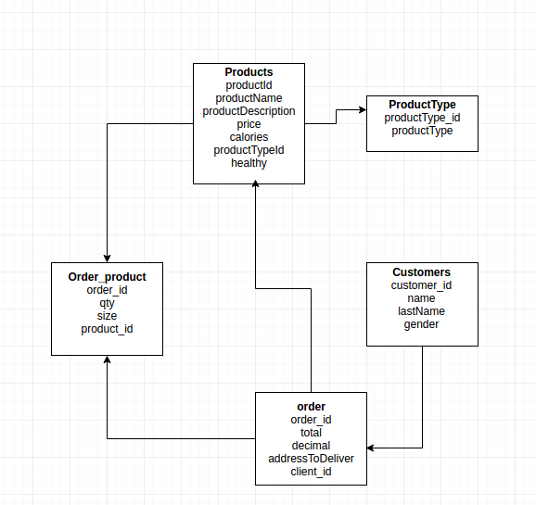

**Database:**

CREATE TABLE customers (

customer_id int(8) NOT NULL,

customer_name varchar(50),

customer_last_name varchar(50),

gender char(1),

PRIMARY KEY(customer_id)

);

CREATE TABLE products (

product_id smallint(6) NOT NULL,

productName varchar(50),

productDescription varchar(200),

price decimal(10, 2),

calories smallint(6),

productTypeId tinyint(4),

healthy tinyint(1),

PRIMARY KEY (product_id)

);

CREATE TABLE productType (

productType_id smallint(6) NOT NULL,

productType varchar(50),

PRIMARY KEY (productType_id)

);

INSERT INTO productType VALUES

(1, 'Breakfast'),

(2, 'Lunch'),

(3, 'Dinner');

INSERT INTO customers VALUES

(1, 'Karina', 'Pizano', 'F'),

(2, 'Pearce', 'Reinsch', 'M'),

(3, 'Christian', 'Martinez', 'M'),

(4, 'Eduardo', 'Garcia', 'M'),

(5, 'Sammuel', 'Villavicencio', 'M'),

(6, 'Mary', 'Lou', 'F'),

(7, 'George', 'Lopez', 'M'),

(8, 'Gerdina', 'Cole', 'F'),

(9, 'Sofia', 'Vergara', 'F'),

(10, 'Thomas', 'Sanchez', 'M');

CREATE TABLE orders (

order_id int(11) NOT NULL,

total decimal(10,0),

addressToDeliver varchar(20),

client_id int(8) NOT NULL,

PRIMARY KEY (order_id)

);

CREATE TABLE order_product (

order_id int(11) NOT NULL,

product_id smallint(6) NOT NULL,

qty int(11),

size varchar(10),

PRIMARY KEY (order_id)

);

INSERT INTO products VALUES

(1, 'Pan con leche', 'Bread with milk', '4.00', 50, 1, 0),

(2, 'Eggs and Sausages', 'Over easy eggs with grilled sausages', '12.50', 456, 1, 1),

(3, 'Sweet oatmeal', 'Oatmeal with raisins, apples, and chocolate chips', '7.80', 200, 1, 1),

(4, 'Pancakes', 'Pancakes served with syrup', '10.67', 890, 1, 0),

(5, 'Ham Sandwich', 'Grilled sandwhich with cheese and ham', '13.80', 777, 2, 0),

(6, 'Salad', 'Salad with crutons and any dip', '67.00', 899, 2, 1),

(7, 'Clam Chowder', 'Clam chowder that thing made from crab', '70.95', 67, 2, 1),

(8, 'Meatball Spaghetti', 'Spaghetti with meatballs and hot spicy sauce', '4.78', 34, 3, 0),

(9, 'Lasagna', 'Italian food is yummy.', '12.50', 450, 3, 0),

(10, 'Grilled Salmon', 'It''s Salmon... that''s grilled...', '15.97', 340, 3, 1),

(11, 'Margarita Grilled Srimp', 'Let''s get KRUNK', '20.01', 180, 3, 1),

(12, 'Ginger Glazed MahiMahi', 'Sweet and Sour yumminess', '17.85', 260, 3, 0),

(13, 'Mac ''n Cheese', 'basic', '8.67', 560, 3, 0),

(14, 'Sweet Potato Burrito', 'vegetarian burrito with sweet potatoes', '6.98', 500, 3, 1),

(15, 'Cheesy Breakfast Pizza', 'best thing in the morning', '7.57', 220, 1, 1),

(16, 'Aussie Omelet', 'Shrimp, Veggies, and Cheese!', '9.49', 310, 1, 0),

(17, 'Breakfast Enchiladas', 'Hashbrowns, cheese, ham, green chillies.', '11.21', 480, 1, 0),

(18, 'Baked Egg Sammich', 'Ham and egg croissant sammich', '6.49', 570, 1, 0),

(19, 'Breakfast Slider', '4 Hawaiian Rolls with scrambled egg, ham, and cheese', '6.32', 590, 1, 0),

(20, 'French Toast Souffle', 'Casserole of bread, cream cheese, egg, and milk.', '9.73', 240, 1, 1),

(21, 'Turkey wild rice soup', 'wild rice in broth with turkey chunks, bacon, and creamy cheese.', '10.72', 400, 2, 1),

(22, 'Minestrone', 'lots of veggies, thick broth', '11.72', 220, 2, 1),

(23, 'French Onion Soup', 'Toasted French bread with melted swiss cheese in a think onion soup', '11.11', 730, 2, 0),

(24, 'Grilled Turkey Sammich', 'Turkey sammich with pepperJack cheese, salsa, and green onions.', '6.42', 500, 2, 1),

(25, 'Pulled Pork Sammich', 'pork with brown sugar rub, baked and served with choice of cheese and green onions.', '7.11', 400, 2, 1),

(26, 'Cucumber Sammich', 'Cucumber, choice of bread, cream cheese, and dill.', '4.55', 130, 2, 1),

(27, 'Ham and cheese sliders', 'Hawaiian roll with ham and choice of cheese.', '1.50', 140, 2, 1),

(28, 'BLT wrap', 'Bacon, Lettuce, Tomato, and choice of cheese.', '6.33', 700, 2, 0),

(29, 'Jalapeno Grilled Cheese Sammich', 'Jalapeno cream cheese, choice of cheese, and jalapeno pita chips on grilled ciabatta bread.', '8.79', 550, 2, 0),

(30, 'Cranberry Spinach Salad', 'Spinach, roasted almonds, and dried cranberries.', '6.21', 300, 2, 1),

(31, 'Juicy Hamburger', 'Juicy', '5.55', 300, 3, 0),

(32, 'Blue Cheese Burger', 'hamburger patty with blue cheese, worcestershire sauce, and mustard.', '7.43', 350, 3, 0),

(33, 'Cream Cheese Jalapeno Burger', 'Cheese burger with jalapenos and cream cheese.', '6.91', 520, 3, 0),

(34, 'Aloha Chicken Burger', 'Grilled Teriyaki chicken, pineapple, bacon, choice of cheese.', '8.12', 670, 3, 0),

(35, 'Chicken Kabobs', 'chicken chunks, green bell pepper, onion, and mushroom on a stick.', '6.10', 400, 3, 1),

(36, 'Chicken Masala', 'Chicen marinated in yogurt and spices, served with tomato cream sauce.', '6.82', 400, 3, 1),

(37, 'Tuna Steak', 'Sweet and tangy', '9.99', 200, 3, 1),

(38, 'London Broil', 'Soy Sauce and garlic marinade.', '7.77', 250, 3, 1),

(39, 'Baby Back Ribs', 'Cumin, chili powder, and paprika on ribs.', '12.21', 450, 3, 0),

(40, 'Grilled Garlic Parmesan Zucchini', 'Grilled zucchini slices with garlic and parmesan cheese sauce.', '5.28', 150, 3, 1);

INSERT INTO orders VALUES

(1, 7.80, '557 Cesar Chavez', 1),

(2, 13.80, '456 Loomey Wy', 7),

(3, 70.95, '233 North St', 9);

INSERT INTO order_product VALUES

(1, 3, 1, 'M'),

(2, 5, 1, 'S'),

(3, 7, 1, 'L');

**Mock Up**

